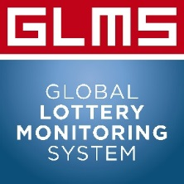

GLMS MEMBERSHIP - PROCESS FOR APPLICATION FOR ASSOCIATE MEMBERS

The Global Lottery Monitoring System (GLMS) was set up in 2015 by the World Lottery Association (WLA) and European Lotteries (EL) to facilitate the sharing of sports trading information as part of the collective effort of its members to help improve sports integrity globally. GLMS partners with sports governing bodies such as the International Olympic Committee, Fédération Internationale de Football Association (FIFA), the Tennis Integrity Unit (TIU) and Union of European Football Associations (UEFA) in combating against match-fixing around the world.

The statutory requirements to become an associate member are reflected in Article 3.4 as follows:
Associate Membership
Associate membership is open to any organisation, interested in safeguarding the integrity of their operations and sports in general, such as (non-exhaustive list): sport organisations, National Olympic Committees, law enforcement authorities, service providers.
Associate members have no voting rights.

The benefits for associate members include:
- Transmissions of relevant alerts at global level from the GLMS operational team
- Provision of education and prevention tools
- Regular transmissions of key information on sports integrity policy and regulatory developments
- Right to ask for full detailed analysis on a certain competition even though they don’t have access to the monitoring platform
- Sponsorship opportunities in relation to Sports Integrity Events organised by GLMS
- Quotes and statements in GLMS communications and website as GLMS associate members
- Right to refer to GLMS in all company public statements and use of the GLMS logo for relevant purposes following prior communication to GLMS General Secretariat
- Access to bi-weekly, monthly and quarterly operational monitoring updates
- Speaking opportunities at events
- Invitation to the General Assembly (no voting rights)

To become an associate member:
Interested parties shall specify in writing their commitment to be part of the cooperation by sending an application letter/email. This expression of interest must be made by the highest level of management of the applicant lottery.
The letter must reflect the following:

- The grounds of motivation to becoming a member
- The overall comprehension and endorsement of the goals of the GLMS association

Associate Members undertake the commitment to make an effort to register – in coordination with the GLMS General Secretariat – all Lotteries they work with and are eligible to join GLMS as individual Members.

Under no circumstances, is a GLMS associate member allowed to share GLMS data and/or resell GLMS services to any parties, which are not already GLMS Members. If a GLMS associate member does not comply to this obligation, the GLMS membership and GLMS services will be automatically discontinued.

The membership fee for national associate members – 5’000 CHF per year.
The membership fee for international associate members – 7’000 CHF per year.
The corresponding documentation shall be sent together with the information form annex to info@glms-sport.org

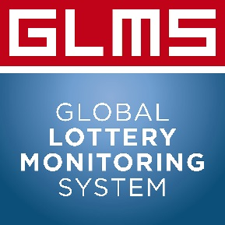

GLMS MEMBERSHIP - APPLICANT INFORMATION FORM (Associate – Supplier Members)

1. GENERAL INFORMATION

  - Full Name of Organisation:

  - Used Name (if different from above):

  - Country:

  - Address of Operational Headquarters:

  - Website(s):

  - Year of establishment:

  - Incorporation form (overall shareholding structure and corporate affiliations):

  - Are you a WLA/EL associate Member (Yes/No – year of membership)

2. Lotteries - clients
- Which are the Lotteries you cooperate with?

3. Your key contacts
Please, provide contact details of your CEO, the CEO assistant, the International relations person and the operational contacts that our technical team will be in touch with for operational matters. You can add 2 additional individuals that can be included in relevant communications of the GLMS.
NAME & SURNAME | POSITION | EMAIL | PHONE NUMBER
 | CEO
 | CEO Assistant
 | Head of International relations
 | Sports betting manager

4. Commitments
- I hereby confirm that in coordination with the GLMS General Secretariat my organisation will make its best efforts to have our client-Lotteries that have eligibility to join GLMS as an individual member join the GLMS

- I hereby confirm that should my company be accepted as GLMS Member, under no circumstances shall it share GLMS data and/or resell GLMS services to any parties, which are not already GLMS Members. Should this be the case, I understand that this will be a reason for ceasing GLMS services and exclusion of my company from the GLMS associate membership.

Date, Signature

